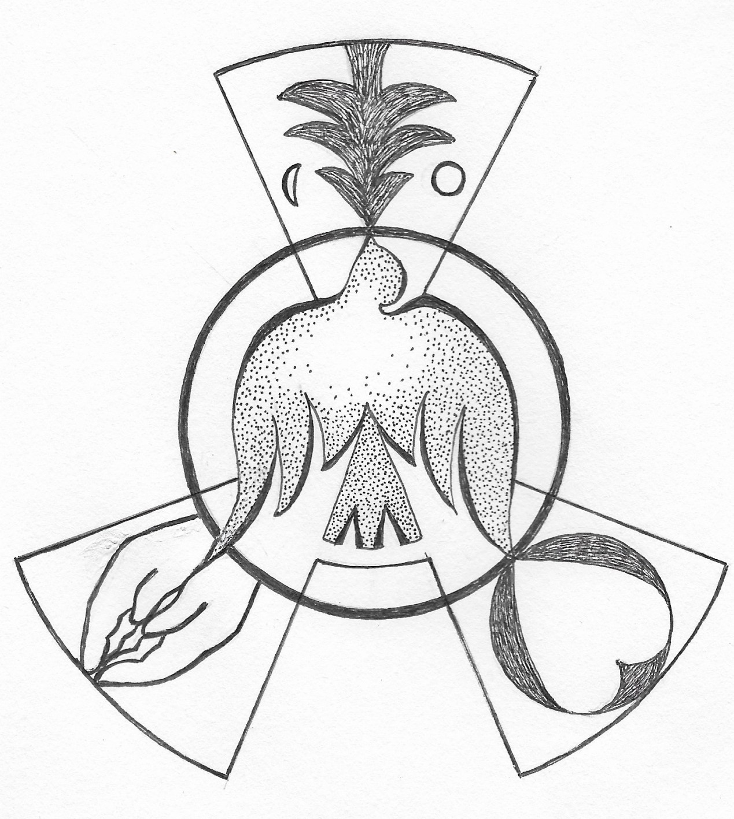
That All May Be One
by Sr. Nancy, Smic

Mosaic 1 - 2017

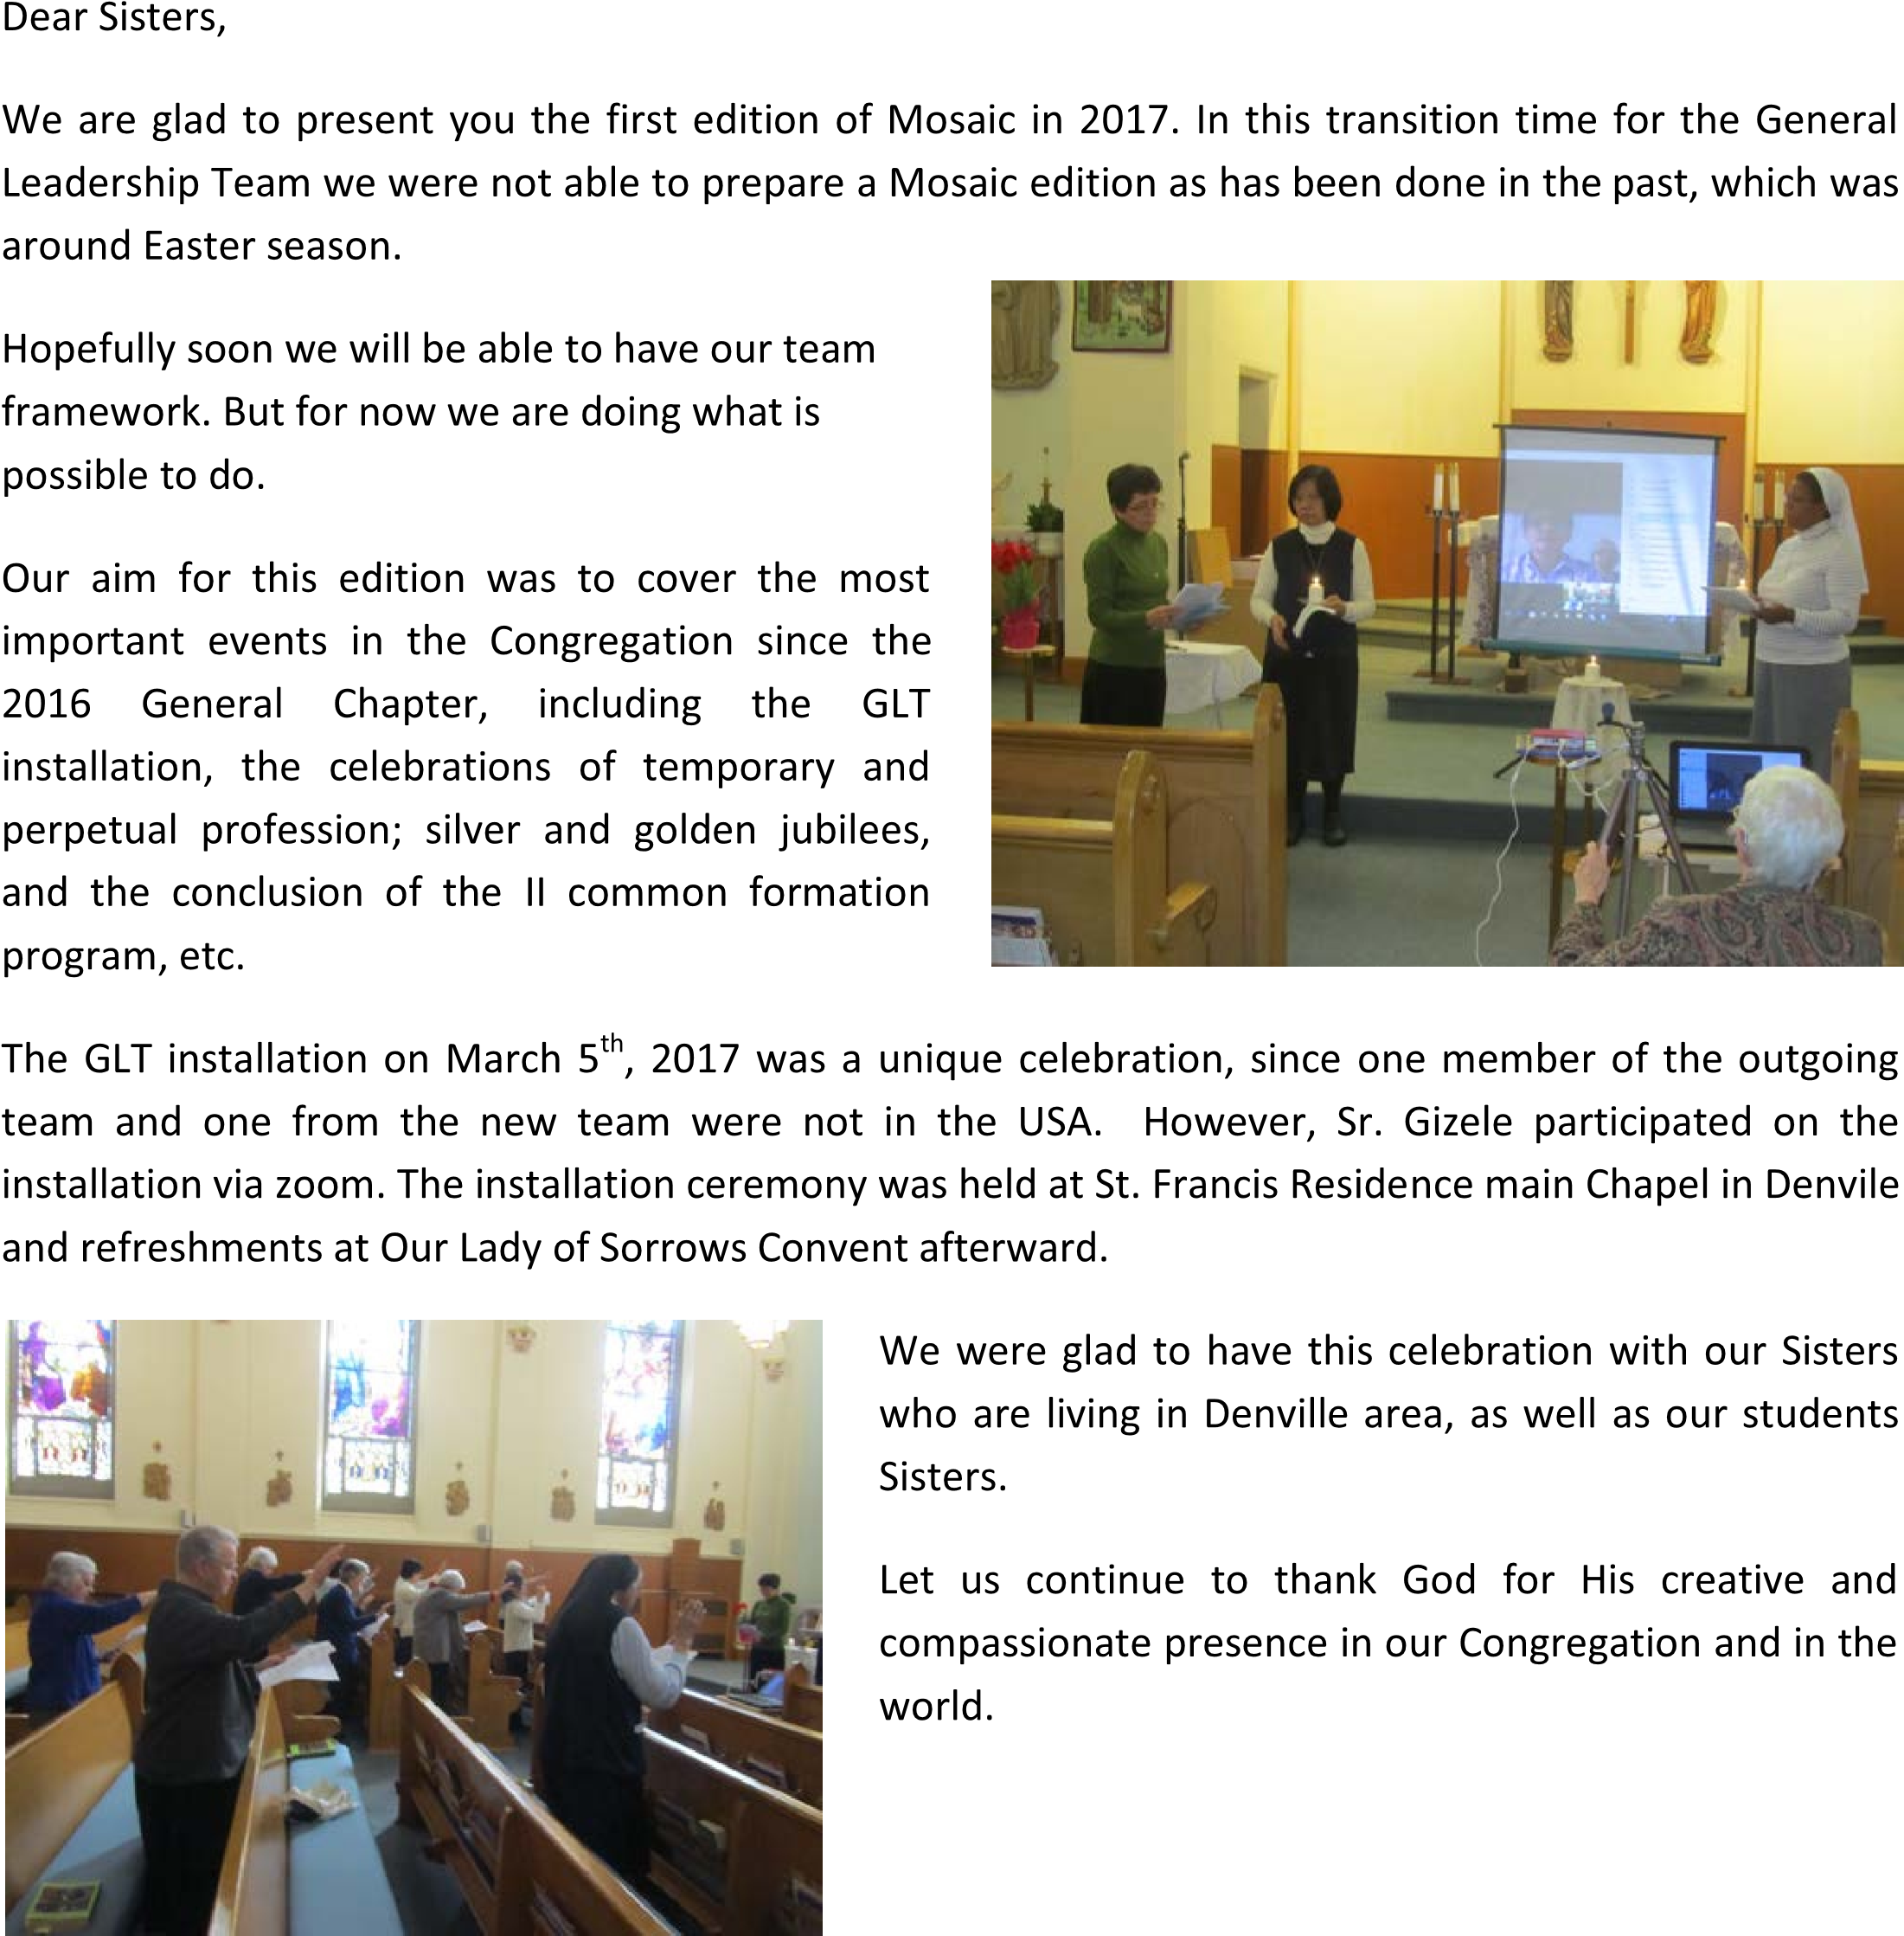
Yours Sisters from the Generalate:

Livramento Beatrice Beatrix Gizele
01

A SPECIAL EASTER OFFERING: TEA CEREMONY
On Easter Sunday afternoon here at our Immaculata Spiritual Center, we experienced a very special and different kind of Season Offering “liturgy”. A Japanese Tea Ceremony teacher, Hashimoto Kiquko (橋本喜久⼦) from Kyoto, Japan came to Tainan to hold a Tea Ceremony for Easter.
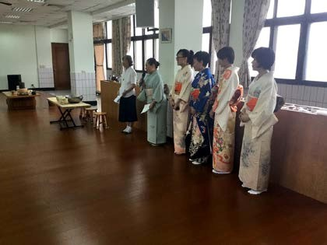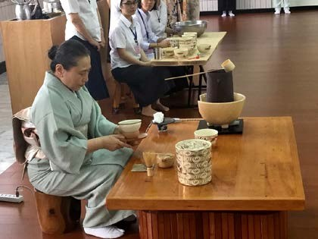
A cup of tea both in Taiwan and Japan signifies sincerity and honor between friends.
However, Japanese has developed this simple sign into a religious “sacrament.” And whenever people do it, it is done contemplatively and beautifully in silence with great reverence.
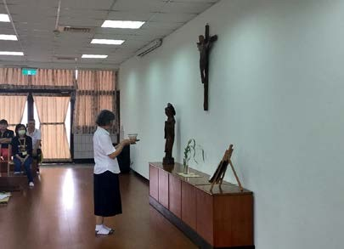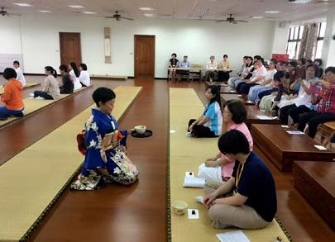
On this Easter Sunday afternoon there were about seventy people, believers, and nonbelievers, Catholics, Protestants, Buddhists and Taoists, sat together in the meditation hall.
In the beginning of the ceremony, the first cup of tea was brought to the altar and offered to Jesus Christ the risen Lord. All the participants sat silently and did only the following things: observed the teacher making tea cup by cup; reverently received the tea brought to you by the server; and drank the tea with gratitude.
The entire “liturgy” was carried on in silence and it lasted for two hours.
It was indeed a deep, contemplative experience of life, peace and love of Easter.

02

GRATITUDE
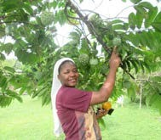
I would like to use this opportunity to express my gratitude for the chance I had to experience the Mission work of our two Brazilian Provinces. As you have been updated through our monthly report, I would really not have much to say because everything about the life in Brazil is in the previous reports.
Leaving my country to Brazil was a great excitement, the people in Brazil are so friendly and full of hospitality, I haven't found myself as a foreigner but as a Brazilian native. Well, food was a bit different from Namibian food but I got adjusted to it, I loved the weather in Bahia the Sr. Emeresiana Hawanga (SMIC) evergreen part of the country.
During this year, we have visited the two provinces in Brazil and I have seen how the sisters are serious at work (pastoral), and I was touched. It surely costs a lot of energy and strength to run a hospital or school, I was inspired by their work and I was encouraged by their commitment in the mission work. Sisters are so lovely, to my surprise every community we visited, sisters welcomed us with gifts; sometimes I couldn't find enough space because I always carried a small suitcase. My heart was moved when I arrived in Santarem, the place of our birth, the holy ground where our founders walked and worked around the Amazon River, only tears that express my feelings. All was just a leaning from our SMIC history but now I have seen, touched and smelled the freshness our history. Thanks for the opportunity.
Challenge: as we all know that the 2016-2017 common formation Asia was the dominant culture just to be honest with you; I had a hard time to live among them especially after Sr. Beatrix's departure to Namibia. I found myself in the air, but what I have always believed is that God is always with me. I have become more matured and stronger because I put all that I went through as positive; the more difficulties came in my way, the more I grew from the lower to the upper. I was able to handle things maturely and calmly. One of the things was due to cultural differences, good I had to bear the burden but I had been motivated by sayings of the leaders: “be aware and sensitive on other people's values,” especially when we learned about cultural sensitivity and community building given by Srs. Beatrix and Silvia.
My life became a bit delighted when we Sr. Veronica arrived, everything became better. She challenged everyone to live a real life, not an artificial one, and stirs us up to participate and contribute fully. Through her leadership skills she helped me to act positively and to be myself.
I am also thankful to my fellow sisters for being together with them during the common formation program. Through challenges that we went together, in diversity we have learned to leave together as SMIC sisters. We are blessed for being in an international Congregation because through that we become more aware of our culture and others cultures, customs and feelings of others as well. And that is how we show the world that we can live together as one family even though we have cultural differences. My thanks to my three formators Srs. Veronica, Silvia and Beatrix for accompanying me during this year and especially to my province/Namibia for giving me this opportunity and contribution to my stay in Brazil in different ways.
My gratitude to our Generalate and to all who contribute to our common formation program, May God bless you all.

03

FIRST PROFESSION OF VOWS AND RENEWAL OF TEMPORARY VOWS, ASIA PROVINCE
On December 8, 2016, Sisters Anna Trần, Jennifer Ngô, Paula Nguyễn (from left to right) renewed their vows at the St. Joseph House in Hochiminh City, Vietnam. The celebrant of the Mass was Fr. Giuse Tôn Khánh Duy, OP.
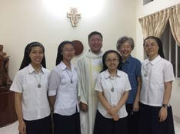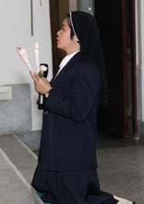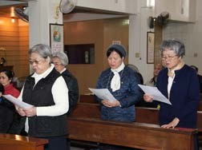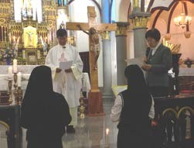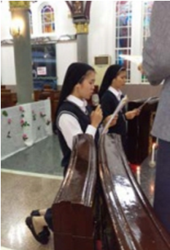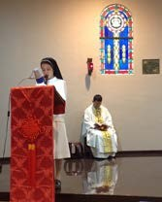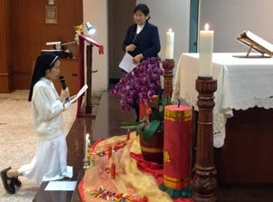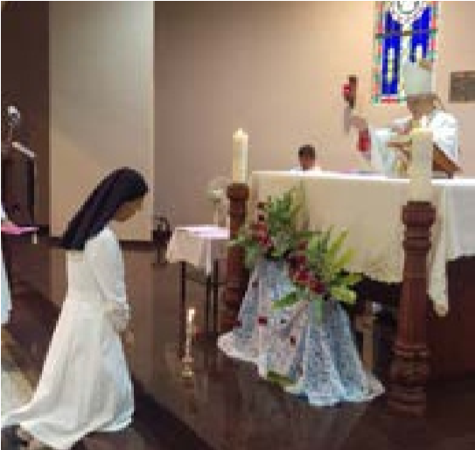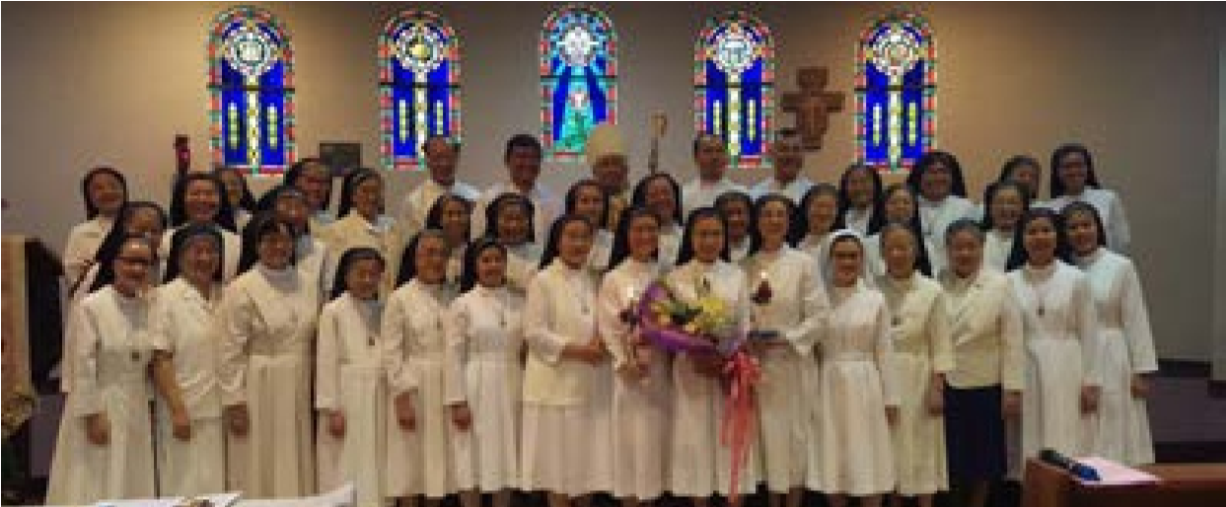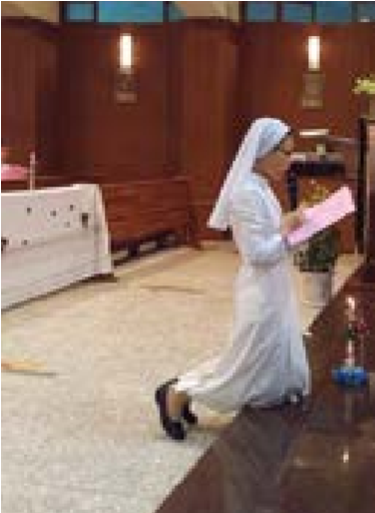
On February 11, 2017, Srs. Laetitia
Trần and Rita Trần renewed their vows at
The Holy Rosary Major Bacilica-Cathedral
of Kaohsiung Diocese, during the 6:30 am
Mass.
At
the
same
time,
Sr.
Regina
Nguyễn

renewed
her
vows
at
the
chapel
of
Tainan,
Provincialate.
In the evening of the same day, February 11,
pm, Sr. Rosa D
8:00
à
o renewed her vows at the
Queen
of
Angels
Parish
Church,
Hsinying,
Tainan, during the Sunday Mass.
Novice
Sr.
Clare
Nguyễn
took
her
first
profession of vows in the afternoon on March 25,
2017
at the chapel of Tainan Provincialate. The
main celebrant was Bishop Bosco Lin of Tainan
Diocese.
After
the
first
vows
of
Sr.
Clare,
Sr.
Theresa Su renewed her vows.
At the same day, Sr. Scholastica Ling, together with Srs. Felicitas Wang, Veritas Yang, Anita Hu and Maria Goretti Wang renewed their temporary vows at 6pm in the Our Lady of Aparecida church/community, Salvador Province, Brazil.
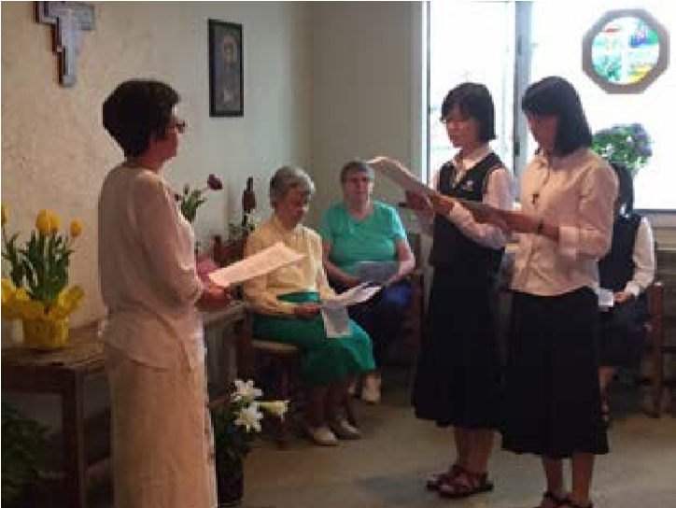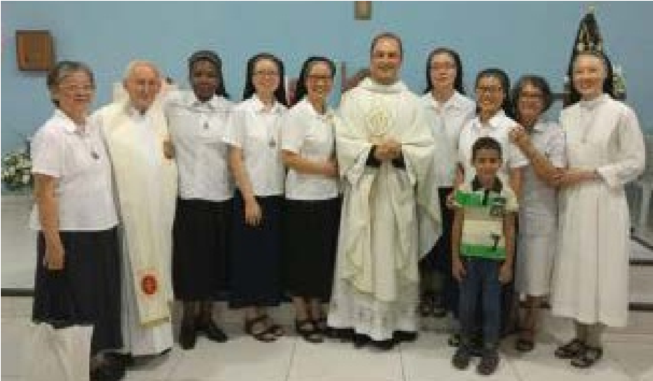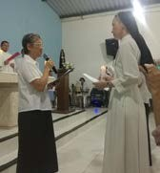On April 17, Easter Sunday afternoon, Srs. Augustina Hoàng and Hannah Ngô (from left to right), our two student Sisters in Felician University, renewed their temporary vows at Our Lady of Sorrows Convent Chapel in the presence of Denville Community, USA Province, Sr. Beatrice, Assistant General Coordinator, and the other SMIC student Sisters . Sr. Livramento, the Coordinator General, received the renewal of vows.

04

TAIZE YOUTH GATHERING IN TAIWAN
Sr. Theresa Su, SMIC
We, fourteen young Sisters of Asian Province, attended the Taize Worship in Taipei from April 28th to 30th. There were more than a hundred young adults joined made up of a diverse group of Christian Churches and two third of them were Roman Catholics. The theme of the event was “Reconciliation in Mercy.”
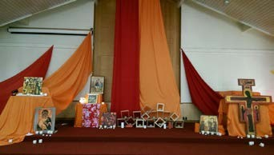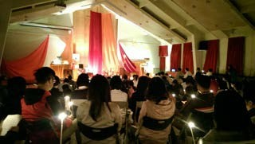
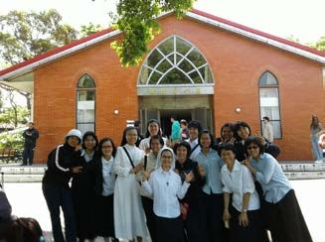
Before the program started, Br. Han Yol Shin of Taize who were the main coordinator of this event, said, “This is a time to rest in God and release all burdens of our hearts.” He gave us a little introduction of Taize Prayer. I was impressed when he introduced the “Taize Cross.” Br. Shin let us look at Jesus' hands carefully. He asked, did we see Jesus is trying so hard to stretch out his hands in order to reunite people from two sites. He used his body as intermediary to sacrifice, to bring peace, and to reconnect people. By His example, we could reflect on our daily actions, and identify if we were also
like Jesus as a sacramental instrument for this world.
One of the most important parts of this event is the “Sunday Worship.” After Protestant and Catholic priests' long discussions and considerations, they came out a reformed “Sunday Worship” which held on the last day of this event; eventually, I can't tell any difference between our Sunday Mass and this reformed Worship. If I have to recognize something, I would say we use different versions of Gospel readings. The most touched part of the Sunday Worship was when we sang Our Father, everyone sat together, hand in hand; no matter which Churches we belong to. When it was time to receive the Holy Communion during the Sunday Worship, two priests from Episcopal Church and Roman Catholic Churches did the service for all participants. There were two long lines for receiving the Eucharist. It was an incredible moment. I felt it was like a separated body, now reunited.
I learn a lot from these two days and experienced a renewing energy burning in my heart. I pray through our prayers and practice bringing peace and hope to the world.

05

HOSTEL TRAINING TSES
by Sr. Beatrix Mokwena smic
A two-year training course that was called “Pedagogical/Cathechetical Seminary (PCS) for hostel educator was installed 1974 in Dornfeld/Gobabis by fr. Philipp Pollitzer OMI, now bishop of Keetmanshoop. We, the SMIC sisters, were in charge of the training course till 2008 when it was closed.
And in 2010, Bishop Pollitzer came with the idea to continue with this course in the South of training people who are already working in Catholic Hostel. But on the same time we saw also the need of unemployed young people.
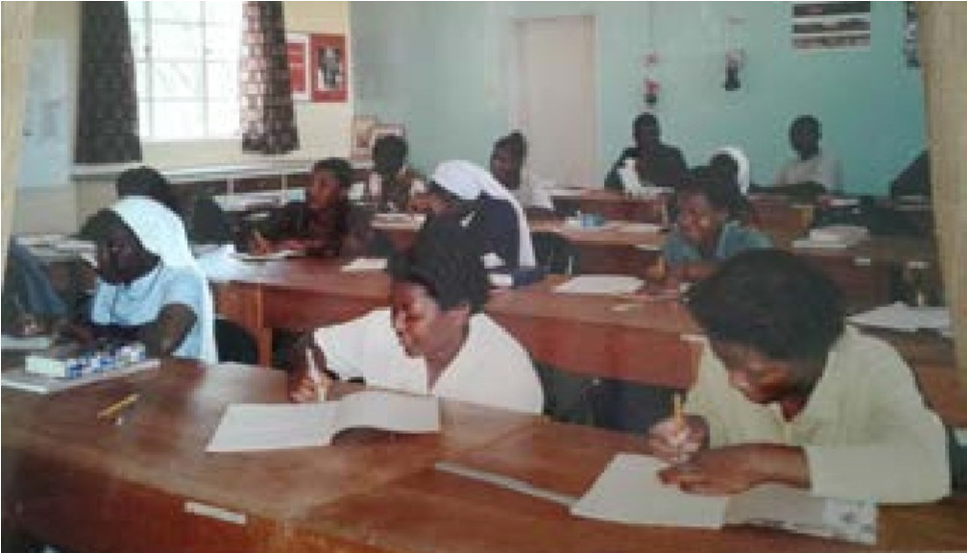
We started the course first as refresher course for those who were already in service as hostel educator. As time went on, we decided to make it as a training course to help unemployed young people in Namibia. Due to those who are in-service we do the training during schools holidays to give opportunity to them to attend the training. We officially started in 2011 whereby people from the North and even the South came in big numbers for the course. The training is just during holidays and twice in a year for two weeks. That means each person has to follow 10 modules to finish the training.. Actually the training is well attended with maximum of 50 to 60 people per course. We invited people from outside (priest, deacons, sisters, lay people and volunteers...) to give classes. However, one married women trained at Gobabis is part of our team.
It was a big success and joy to see the fruits of our work from 2011to May 2017. So far twenty young people and two Religious sisters of Francis de Sale sister and Benedictine sister are graduated.
This training gives many people the opportunity to get work in RC hostels and Government hostels and even in kindergarten/Pre-school fields.
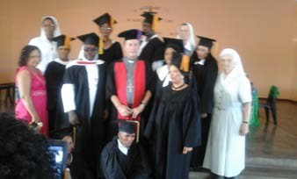
With great gratitude we are thankful for all who finished the training and been part of our team and helping us in different ways e.g. giving classes or helping with cooking.
As administrators Miss Maritjie Hatzenberg and myself Sr. Beatrix, visit all the Catholic hostel three times a year. We want to see that the trainees are doing the work correctly and to advise them. Thank God who gives us the grace and strength to continue with this important education to help our Kids spiritually, mentally, socially and moral value.
The courses of this type are really important both to the education of a Namibian child and the Catholic Church in Namibia.
06

A TIME FOR ACTION
by Sr. Joanne Riggs, smic
After we returned home from the general chapter last November we decided on a plan to share the experience of the chapter with our sisters who could not attend. To accomplish this, we set up a series of Zoom calls for the members of the US Province. These meetings were scheduled on Saturday afternoons in January, February, April and June.
On January 14th we shared a 'flavor' of the chapter with our sisters by describing the structure of the days, the base and consensus groups, the social events we attended and even the food! Each one of the delegates took an aspect of the chapter and shared with the group their own experience of our time in Taiwan.
The delegates thought that each of the scheduled calls would be done around one of the chapter directives. The exception to this was the directive on prayer, which we hope to experience in person by replicating the small groups we had at the chapter in our provincial gathering in August, 2017.
On February 25th, we did our second call and its purpose was to discuss one of the chapter directives—in this case, “our sensitivity to the cry for human dignity that comes from global realities impels us to strengthen our multicultural communion within and outside of the SMIC community”. In preparation for the call each of the sisters received a prayer to pray before the call, reflection questions related to the directive and a question sent out ahead of time called a 'loop'. The sisters were asked to respond to the loop question in writing before the next call, so that their responses could be shared at the meeting. Some of the responses to the February call were:
“God's wisdom created our variety.”
“Jesus said---what we do to others we do to Him—are we listening with our hearts?”
“The sense of 'superiority' that our country imposes on others resulting in such actions as: a ban of refugees/immigrants and disregard for their essential needs—food, shelter, health care and employment.”
When asked to select their top two priorities: the sisters overwhelmingly selected:
- Immigration/refugees
- Care for creation
As the two areas that the province should focus on in the next couple of years.
We repeated this process again on our subsequent calls of April 8 when we discussed the direction statement: “We are determined to respond to a clear call to mission beyond borders. This motivates us to courageously expand our mission networking.” Again, some of the comments of the sisters were:
“In our general chapter discussions, this direction statement had a real urgency within the group, expand who we are—more courageous in efforts—include others—collaboration-work together with all people to bring the message of Jesus”.
“Mission begins with us, we have to love one another then can branch out—all of our outreach begins with us”'
“There are no borders for SMIC.”
And on June 10th we discussed: “In Franciscan reverence, we respond to the pain of mother earth by committing ourselves to intensify our ecological solidarity.” Again, our sisters said:
“the greatest pain is that of human ignorance.”
“ indifference to the poor, waste, lack of reverence for all creation”.
“selfishness, lack of concern, it's too much trouble.”
The whole purpose of doing this is to dive more deeply into these issues at our annual gathering and plan together what concrete actions we can realistically take to support the directions that were set by our general chapter last November. Our annual gathering is scheduled for August 28-Sept.1—pray for us and we will for all of you.

07

CLOSING CELEBRATION OF THE COMMON FORMATION PROGRAM
by Sr. Marta Helena de Carvalho
"We will be gathered here as they were in Jerusalem, for it is only when we are united that the Holy
Spirit comes to us."
In an atmosphere of longing and with a vibrating heart and with joy to celebrate the Feast of Pentecost and the Closing Celebration of the Common Formation Program was held on June 4, in Feira de Santana. We can say that we live a true "Pentecost", living with different cultures and languages because of the faith in our Lord Jesus Christ in our midst.
Last year, the Province of the Holy Cross welcomed our Sisters Emeresiana, Scholastica, Anita, Veritas, Maria Goretti and Felicitas to participate in this Common Formation Program in preparation for their Final Vows at the Missionary Sisters of the Immaculate Conception of the Mother of God and to spend time together with all of us and God's people.
The celebration was beautiful and full of emotions and we only have to thank God for the success and journey of this Common Formation Program. For sure, it is true that there have been many opportunities for growth and joy. There were also some challenges and problems that were accepted in the faith and trust of the One who called us.
I praise and thank God for the strength, determination and courage given to Sister Silvia. A real hero! By the grace of God, you have come to the end with merit. Everything was beautiful and well done from the start. This Program certainly marked our lives and the Holy Cross Province showed that it can and can make it beautiful. Congratulations Silvia for your potential, for beating!
The Brazil – Bahia, the Holy Cross Province, the people of St. Joseph Worker's parish, and specially the Community of St. Francis Xavier wants to say thank you very much, dear Sisters, for this time living among us. Wherever you are, remember that we will remain with open hearts and arms to receive you when you feel homesick and want to return to our fellowship.
May the Holy Spirit that descended upon the Apostles and Holy Mary in the Upper Room, descend upon each one of us and may this same Spirit illuminate and lead the footsteps of our Sisters who have ended their journey among us.
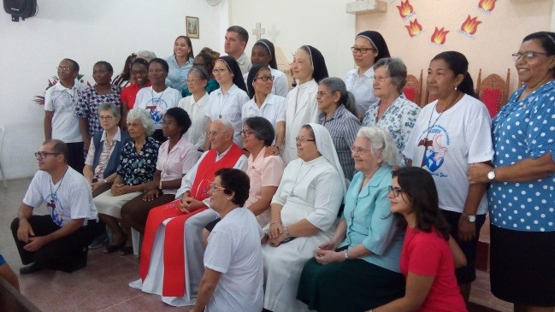

08

CORONATION OF OUR LADY AND ANNIVERSARY OF THE SANCTUARY MARK
THE CLOSING OF THE MONTH OF MAY IN THE CHURCH OF THE GOOD ANGEL by OSID Team
One of the moments of great significance for the Church, the coronation of Our Lady marked the closing of the month of May and filled with emotion faithful and devout on May 27, during the Mass celebrated in the Shrine of the Blessed Sweet of the Poor (Lago de Roma). The image chosen for the coronation of the Mother of Jesus was that of Our Lady of Fatima, a tribute to the 100th anniversary of the apparition of Our Lady in Portugal. The occasion became even more special with the participation of children from the Sanctuary catechesis, including Sister Dulce (OSID), Gabriel Weber, the child protection partner at the Obras Sociais of Sr. Dulce (OSID), who did the coronation. The little ones played the story of Our Lady of Fatima and the three little shepherds, which brings the message of peace and transformation of hearts for good. The festive Mass also commemorated the Day of Dedication of the Church of the Immaculate Conception of the Mother of God (official name of the Shrine of the Mother of the Poor), which celebrated its sixth anniversary.
"Today we are celebrating because we celebrate the closing of the month of May, the feast day of Our Lady, thus remembering the coronation of the Mother of Jesus Christ as queen in heaven and on earth. This date is also a source of joy because we celebrate the dedication anniversary of the Shrine of Sister Dulce, the day on which this house was dedicated to the Immaculate Conception of the Mother of God; This shrine which is always open to welcome and give spiritual support to those who need it most, "said Fr. Giovanni Messias, Rector of the Sanctuary of the Blessed.
The Sanctuary of the Good Angel has been in operation since 2003 and was erected thanks to the help of believers and donations. With capacity for more than 1,000 people seated and the Church began to be built in 2002 from the Brick Campaign in the same place where in the 1940s the Bahian Nun built the Workers' Circle of Bahia and Cine Roma. The dedication of the Sanctuary of Sister Dulce happened on May 27, 2011, when it became recognized as a religious space by the Church and was named Church of the Immaculate Conception of the Mother of God. "That we all may be one."
In the South, the Sisters gathered with Sr. Beatrix, Sr. Cecilia, Sr. Clara and myself on a Saturday. The other communities were done by Sr. Clara. Everywhere we started with a prayer, and reflect on one of the daily reflection. Sr. Clara, gives a short introduction.
It was necessary to start with the “Statistics” before we sharing about the Restructuring, Constitutions, Complimentary document, and the changes that is made. Our Sisters was touched to see how we reduce in numbers year by year. Therefore it was easy for them to try the new model. They were having some question for clarification, but it was easy for us to answer it.
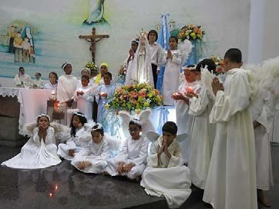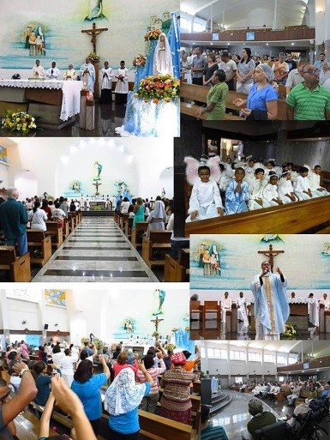 The Sisters in the Namibia Province was enthusiastic and they open to try the new model and see how it will work. They responded positively.

Yours: Sr. Emelda Koper Smic/Namibia
09

OUR LIFE IN CURURU MISSION
by Claudia Regina Moraes
Usually sisters ask us: what do you do in Cururu? So now I'm going to tell you something about our life here in this holy ground.
Since we are here we have done different activities according to the necessities of Munduruku people. For many years, in the beginning, sisters and priests worked more caring of the evangelization, education and health.
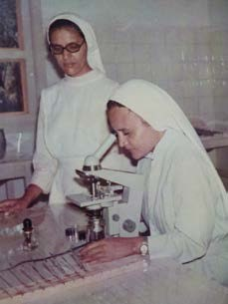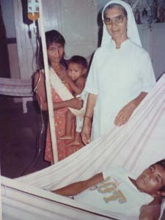
Then, in the decade of 80 all the indigenous people in Brazil was suffering abuse in their most important rights. So, that time Catholic Church, in Brazil, started to help them how to become strong as a people and fight for their rights together with another tribes. The Conference of the bishops created an important institution named CIMI (Conselho Indigenista Missionário) especially to care of the mission with the indigenous people. The first meeting of the indigenous leaderships was in Cururu Mission. The purpose of their meeting was put different people together and teach them how to fight together for their rights.
Politically, the government wanted to transform all the originals people in ordinaries citizens. Many tribes were disappearing fast, especially because rich people were looking for their lands. How you can see a new necessity appear, and our sisters and brothers Franciscan included one more activity in their mission – to give special attention for that new moment in the life of Munduruku People.
In 2003, after hard fighting, Munduruku people received the document of their land.
And now, what must missionaries had to do? The services of education and health were not receiving a good assistance by the government. Then, once more missionaries have to do something. Our sisters, with help of CIMI, start to offer orientation to the leaderships and support them in their fighting. One of our sisters who had had long experience in popular education, Sister Thaís, helped the indigenous teachers to find the best way to start a specific education for them. This kind of school is allowed in Brazilian Constitution. But is not ease to get it. Nowadays, sisters were not anymore working at school because there are already people prepared to lead the school.
About health, sisters served Munduruku people for many years. Since 1912 until 2000, when government sent professionals to care of Munduruku people's health. But we continue helping them in this service because they use part of our house to this service.
The last sister who worked in the health was Sister Conceição Rocha who lives here since 1973. She has spent all her religious life here. Now she is going to be 80 years old, but you can't imagine how young is her soul and how many things she can do. She is our bank of knowledge, experience and enthusiasm.

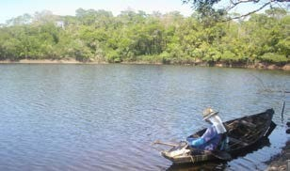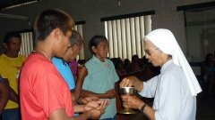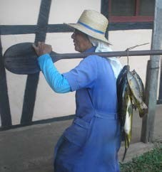

10

So, I think you are asking now. Why sisters still have to stay there? Yes, now has been a new time for us. As we are no more in charged for that activities, we finally can dedicate more of our time and of our life preparing leaderships to help us as missionaries. We have been preparing them to different apostolates.
Many of them are able to celebrate in Sunday days. Since we celebrate 100 years of presence in here we have been offering more formation about Liturgy, Bible, History of our Church and Mission. Just now we are preparing formation for Minister of the Word. Another activity has been translating songs, readings and all material for formation from Portuguese to Munduruku.
Another important activity is visiting their communities that are many. We may visit them and attend their necessities in the Sacraments of Baptism, 1 º Holy Communion, Confirmation, Matrimony and Mass. This year we are three Sisters in our community here, but still attend many apostolates.
. 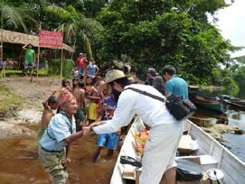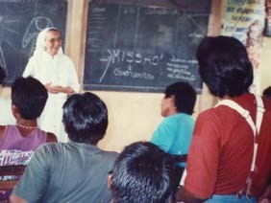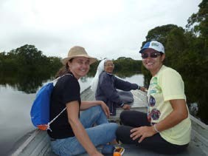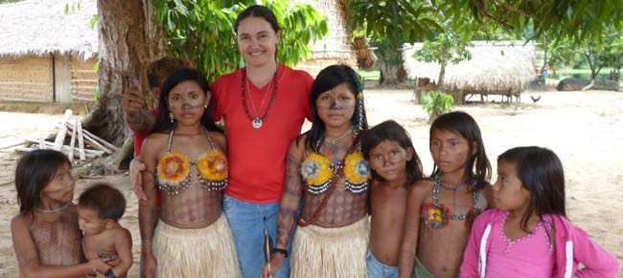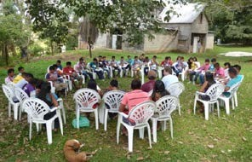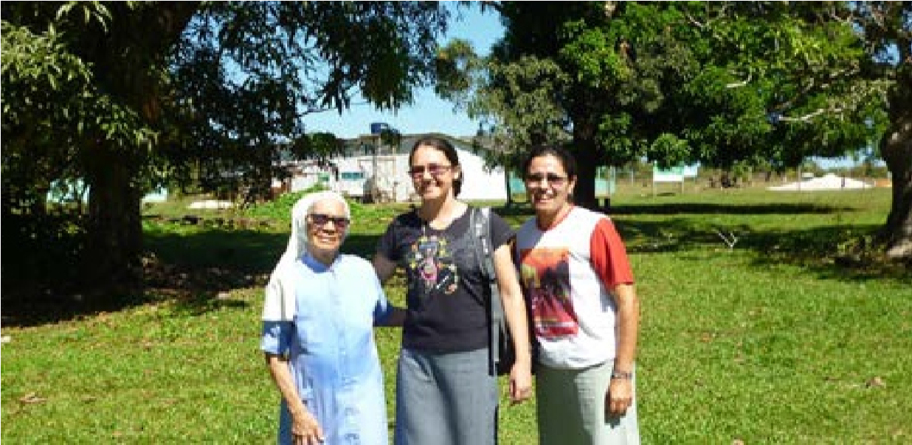 if you want stay with us for an experience you are always welcome.

From the left: Sr. Conceicao Pinho
Sr. Claudia Moraes
Sr. Aparecida Carlos.

